
FACULTY OF ENGINEERING & TECHNOLOGY
Department of Computer Engineering 01CE0607 - Software Engineering – Lab Manual

Practical 1
Problem Statement with Purpose, Scope, Literature Review, and Future Scope(16 pt-bold-Times New Roman)

Aim: Identify a relevant problem or project definition. Write a detailed problem statement for the system, along with its Purpose, Scope, Existing system details with a literature review and mention Future scope of the system.

Password Strength Analyzer

- Introduction
An app built in Python and Flask aims to find the strength of given password, how strong or weak it is and giving suggestions on how to improve it.

Problem Statement

There are a lot of password breaches every year exposing many accounts and their important information, many people still use same password everywhere and every online account, many people cannot verify that if their password is strong enough or not, so it is very important to make sure your password is very strong and it can’t be breached using any kind of brute force attacks by the hackers trying to breach your accounts.

Purpose of the System

The primary purpose of the Password strength analyzer is to let users know about their password strength and let them understand different ways to improve it. The better password will be the harder it will be to brute force it and hack into the user’s account. This system will help users make random very powerful passwords that has high complexity.

Scope of the System

The scope of the Password Strength Analyzer includes the following key functionalities:

    - Analyze the complexity: An inbuilt python password character checker that will check each character of the password and give its strength value.
    - Random password generation: it will generate very powerful random high complexity password.
    - Web tool for users: this complexity checker will be on website so it is easily accessible for all users online.

Shrey Sanja (92301703054) 1
6EC3 - A Batch

FACULTY OF ENGINEERING & TECHNOLOGY
Department of Computer Engineering 01CE0607 - Software Engineering – Lab Manual

- Character complexity points: each character from alphabets to numbers to different special characters will have their own complexity points.
- Password breach possibility: this tool will show possibility that the hackers will be able to breach this password.
- Password brute force time: based on the password complexity how much time will it take for the hacker to breach the password using brute force attack with modern brute forcing tools.

1.4 Limitations

This system will be limited to showing the password strength and random password generation. There will be suggestions for the password. There will be nothing more than that.

Recent advancements in GPUs make it easier to do high processing brute-force attacks and other smart attacks on the login and authentication systems.

This analyzer can only tell if the password is strong or not but can not force the user to take the action and choose the new stronger password so it is only limited to suggestions and informing the user not taking actions.

1.4 Existing System and Literature Review

Table:1 Existing System Study
Title | Author | Year | Method | Advantages | Disadvantag es | Tools used | Remark
Password Strength Tester | Raj Singh, Harsh Kumar Kashera | 2023 | This work will help in evaluating the security of authentication means based on user-chosen passwords. | Compares multiple attack methods fairly | They bypass hashing entirely for analysis | John the Ripper | Most users pick weak passwords, enabling fast early attacks
Strategies for Resolving Security | Gladwin Mendez | 2006 | The research used a mixed experimental + field-study approach. | Proposes practical improvements for home Wi-Fi security | Focused mainly on home users in one city, so global behavior may differ | NetStumbler for WLAN | Most home Wi-Fi networks remain poorly  secured
Analyzing Password Strength | Martin M. A. Devillers | 2010 | The study used a large- scale empirical + statistical analysis approach based on the leaked RockYou dataset | Massive real- world dataset (32M  passwords) | Dataset from one breach (RockYou) this creates demographic bias | RockYou password corpus | Most users follow predictable patterns, making over 90% of passwords statistically weak.
Analyzing  Password | Shiva  Houshmand | 2011 | probabilistic context-free  grammars trained on real | Measures  strength based | Requires large real  password datasets | PAM tool | It proves  that
Shrey Sanja (92301703054) 2 6EC3 - A Batch

FACULTY OF ENGINEERING & TECHNOLOGY

Department of Computer Engineering 01CE0607 - Software Engineering – Lab Manual
Strength & Efficient Password Cracking | Yazdi |  | leaked passwords | on actual crack probability | for training |  | probability- based strength estimation + smart modificatio n beats length/symb ol rules
Password Strength Analyzer That Can Accurately Assess the Security of Passwords | Rohit Ashok Bagde, Roshit Hadge (Students), Sagar Tarekar (Guide) | 2023 | Uses a hybrid approach: rule-based checks + dictionary/pattern detection+ Machine Learning (SVM, Random Forest) | Detects complex patterns and finds hidden weaknesses | Needs large training datasets, ML models add complexity | ML models (SVM,  Random Forest),NLP techniques | Traditional meters are outdated. Combining ML + NLP  + context gives better password  evaluation
Encouraging Users to Improve Password Security and Memorability | M. Yıldırım,  I. Mackie | 2019 | Web-based empirical study with 308 students split into control vs experimental groups. | Users created much stronger passwords without strict rules, Better memorability over time | Academic environment (not real-world apps), Participants were students only | Password Meter, How Secure Is My Password. | Persuasive guidance + example methods outperform strict password rules.
A  Developmenta l Perspective on Weak Passwords and Password Security | James E. Weber, Dennis Guster, Paul Safonov | 2008 | 273 students created “important” passwords. Researchers measured complexity, hashed them (DES + MD5), then  cracked them using John the Ripper on a Linux cluster. | Real passwords from users (not synthetic),Actual cracking performed (not theory) | Only students sampled, Old hashing methods (DES/MD5) | John the Ripper, Linux 16-processor cluster, DES & MD5  hashing, SPSS | ~29%  passwords cracked. Over 88% were personal (names, dates, words).  Numbers- only passwords were the weakest.  Random passwords were  strongest.
Password Security: Best Practices and  Management | Hamzha Hussain | 2022 | Literature review + comparison of prior studies on password  habits, reuse, policies, | Clear real-world guidance, Introduces high  vs low | No original experiments,Relies heavily on past  research | Comparative literature analysis, case  studies, | Strict or vague password  policies
Shrey Sanja (92301703054) 3 6EC3 - A Batch


Strategies |  |  | memorability, and | sensitivity |  | password | backfire.
 |  |  | password managers. | accounts model |  | policy | classificatio
 |  |  |  |  |  | frameworks | n + long
 |  |  |  |  |  |  | passwords +
 |  |  |  |  |  |  | password
 |  |  |  |  |  |  | managers +
 |  |  |  |  |  |  | 2FA.
Passwords – | Gary C. | 1996 | Analytical security study: | Clear | No controlled user | RFC 1244 | Passwords
Strength and | Kessler |  | reviews real password | explanation of | experiments,Based | guidelines, | are
weakness |  |  | practices, explains attack | password | on older Unix | entropy | inherently
 |  |  | techniques. | entropy, Covers | limits (8 chars) | calculations, | weak
 |  |  |  | real attack |  | brute-force | because
 |  |  |  | vectors |  | probability | humans
 |  |  |  | (spoofing, |  | tables | choose
 |  |  |  | replay, social |  | (Schneier) | predictable
 |  |  |  | engineering) |  |  | secrets.
 |  |  |  |  |  |  | Even long
 |  |  |  |  |  |  | passwords
 |  |  |  |  |  |  | give low
 |  |  |  |  |  |  | entropy
 |  |  |  |  |  |  | unless
 |  |  |  |  |  |  | character
 |  |  |  |  |  |  | diversity is
 |  |  |  |  |  |  | high

Future Scope
The evolution of Password Strength Analyzer will go forward with advancements in technology and the growing demand for enhanced user experiences. The future scope includes:

Smart algorithms to find out recent password breaches:

  - We will integrate better algorithms to search the web constantly to find out recent password breaches.
  - people will be know if their kind of passwords were breached by the recent attacks or not
  - algorithms will use web APIs and scraping to get the accurate data of password breaches

AI password complexity explanation

  - There will be special feature given which will activate the AI and it will analyze the complexity and give the explanation about the password
  - Weather Password is maintainable or is it easy to remember or is it hard for hackers and brute force attacks
  - It will also be equipped with latest trends and tools so it can know about the password security systems and will help user put their password safe place on the web.



Offline minimal desktop tool:

  - This tool will be having the password analyzing algorithms of our web tool but it will be locally offline usable.
  - It will instantly help out users to check their password strength without needing of internet connection
  - It will be very small and minimal application to deliver the output quickly.

Special Vault to manage and store passwords:

  - We will create a special Vault to store all the account passwords in one secure space that will use advanced algorithms to keep the passwords secure and safe forever
  - This tool will allow auto adding the passwords when logging to the different accounts whose passwords are saved in the vault
  - It will help users with timely info if the user needs to update their password or not based on if any data breach is found

Chrome Extension:

We will create a chrome store extension that will help user’s directly check any password they are entering in any website if it is strong & safe or not

2. Conclusion
We learnt to identify the problem statement and how to organize the plan and how to execute it and also read a few articles that were relevant to our project to gain good knowledge about what we are going to encounter in this project and how can we solve the problem we see in the password strength.

References:-
https://ijariie.com/AdminUploadPdf/Password_Strength_Tester_ijariie20152.pdf
https://www.cs.ru.nl/bachelors-theses/2010/Martin_Devillers 0437999 Analyzing_password_strength.pdf? utm_source=chatgpt.com
https://scispace.com/pdf/analyzing-password-strength-and-efficient-password-cracking-3fqffphwii.pdf? utm_source=chatgpt.com
https://link.springer.com/article/10.1007/s10207-019-00429-y?utm_source=chatgpt.com https://www.researchgate.net/publication/ 237748045_A_developmental_perspective_on_weak_passwords_and_password_security?utm_source=chatgpt.com



Practical-2
Planning and Scheduling, for System Development
Aim: Perform Project Planning & scheduling by define and design effective policies, methodologies, and strategies to achieve the objectives of the selected system (Mention your selected System). Create a schedule by assigning tasks, allocating resources, and estimating budgets and time frames.

Project Planning and Scheduling involve defining project objectives, breaking down development tasks, allocating resources, and estimating timelines to ensure successful delivery. For the Password Strength Analyzer, planning includes defining security requirements, designing the analyzer architecture, implementing strength evaluation logic, integrating attack-detection rules (dictionary, pattern, entropy), and testing usability.

Scheduling assigns milestones for core modules such as password evaluation, real-time feedback, reporting, and optional API integration. A clear timeline helps track progress, reduce security risks, and ensure efficient use of development resources.

Users and organizations often struggle with weak, predictable passwords, leading to security breaches. The Password Strength Analyzer automates password evaluation using entropy checks, pattern detection, and rule-based validation. The system will provide real-time feedback, crack-time estimation, weak-password alerts, and improvement suggestions—resulting in stronger credentials, better user awareness, and improved overall cybersecurity posture.

Project Planning and Objectives
Effective project planning defines goals, tasks, resources, and schedules, ensuring a smooth development process. The Password Strength Analyzer project focuses on detecting weak passwords, providing real-time strength feedback, and improving user security awareness through entropy analysis and pattern detection. The system aims to offer a user-friendly interface along with secure and accurate evaluation of password data. The planned development steps ensure completion within the designated timeline while effectively meeting cybersecurity and user requirements.

Choice of Process Model: Waterfall Model
The Waterfall Model follows a simple step-by-step development process where each phase is completed before moving to the next. This approach fits the Password Strength Analyzer project because the main requirements—like password strength checking, entropy calculation, and pattern detection—are clearly defined from the start and are unlikely to change much. Using Waterfall helps keep the development organized, ensures proper testing at each stage, and leads to a stable and secure final system.



Reason for choosing waterfall model

Simple Project Structure: The Password Strength Analyzer follows a straightforward flow, making Waterfall easy to manage and understand.

Easy Progress Tracking: Each phase has clear completion goals, allowing better monitoring of development progress.

Strong Focus on Security Design: Early planning helps finalize password rules and security logic before coding begins.

Suitable for Small Team Development: Waterfall works well when development is handled by a small or individual team.

Stable Core Functionality: Password analysis logic does not change frequently, making sequential development practical.

Quality Control: Each stage is reviewed before moving forward, reducing chances of major errors later.

Predictable Timeline: Fixed phases make it easier to estimate delivery time.

Phases of the Waterfall Model Applied to Password Strength Analyzer Requirement Analysis
In this phase, the security needs and system goals are clearly identified. Input is collected to understand how passwords should be evaluated and how feedback should be presented to users.
Key Requirements for Password Strength Analyzer:
Password input and validation
Strength scoring using entropy and rules
Detection of weak patterns and common passwords Real-time feedback and improvement suggestions Crack-time estimation
Secure handling of password data and report generation
Deliverable: Requirement specification document for the Password Strength Analyzer.


System Design

This phase converts requirements into a technical blueprint for development. The system architecture, logic flow, and database structure are planned.

Design Steps:
- Define database structure for storing analysis results and logs (if required).
- Create UML diagrams such as use case, activity, dataflow, and class diagrams to represent system behavior.
- Design the password analysis logic (entropy calculation + pattern rules).
- Develop UI mockups for easy user interaction.
Deliverable: Design documents, database schema, system flow diagrams, and UI layouts.

Implementation

The actual development of the Password Strength Analyzer based on the design documents takes place in this phase. Developers focus on building individual components and integrating them progressively into a complete system.

Development Steps:

  - Build the Password Input Module to securely accept user passwords for analysis.
  - Create the Strength Evaluation Engine to calculate password strength using factors such as length, character variety, entropy, and common-pattern detection.
  - Develop the Rule-Based Analyzer Module to identify weak passwords (dictionary words, repeated characters, sequences, etc.).
  - Implement the Feedback & Recommendation Module to provide real-time suggestions for improving weak passwords.
  - Add the Reporting Module to display strength scores, vulnerability types, and improvement tips.

Deliverable: Functional system modules for the Password Strength Analyzer.


Integration and Testing

  - After individual modules are completed, they are integrated and thoroughly tested to ensure smooth interaction.

  - Testing Includes:
    - Unit Testing: Verifying each module (password input, analyzer, feedback system) independently.
    - Integration Testing: Ensuring proper data flow between evaluation and feedback modules.
    - System Testing: Validating the complete Password Strength Analyzer for accuracy, performance, and user experience.
  - Deliverable: A fully integrated and tested Password Strength Analyzer.

Deployment and Maintenance

In this phase, the Password Strength Analyzer is deployed on the target server or cloud environment, followed by user onboarding.

Deployment Steps:

- Deploy the application on hosting infrastructure (local server or cloud).
- Perform basic user training or documentation sharing.
- Provide ongoing maintenance to fix bugs, update rules, and improve detection logic.

Deliverable: Fully operational Password Strength Analyzer with post-deployment support.

Project Scheduling
Scheduling is a vital part of project planning that organizes tasks, resources, and timelines to ensure timely completion. It involves dividing the project into phases, defining dependencies, estimating development duration, and assigning resources accordingly.
For the Password Strength Analyzer, scheduling ensures systematic development while maintaining quality, security, and performance constraints.

Purpose of Scheduling

- Organize Tasks: Establishes a structured roadmap for completing all required development activities of the Password Strength Analyzer.


- Define Priorities: Identifies task dependencies so critical components like the strength evaluation engine are developed before testing begins.

- Allocate Resources: Ensures developers, security researchers, and testing tools are available for each development phase.

- Monitor Progress: Tracks project progress against planned milestones and deadlines.
- Avoid Delays: Reduces the risk of project overruns through proactive planning and risk management.

Key Elements of Scheduling in Password Strength Analyzer

- Task Identification:
Identify specific tasks required to develop and deploy the system, such as requirement analysis, algorithm design, module implementation, testing, and deployment.

Task Sequencing and Dependencies:
Some tasks depend on others to be completed first. For example:

- The Strength Evaluation Engine depends on rule definition and algorithm design.
- The Feedback Module depends on the output of the evaluation engine.
- Testing can only begin after all modules are implemented.

Estimating Task Duration:
Estimate the time required for each activity based on technical complexity, algorithm research, and available team members.

Resource Allocation:
Assign responsibilities based on expertise. Example:
- The Backend Developer designs and implements the evaluation logic during weeks 1–3.
- The Security Analyst defines password strength rules and testing datasets.
- QA Engineers conduct testing during weeks 8–9.

Milestones:
Define key checkpoints such as completion of requirement analysis, implementation of the evaluation engine, testing completion, and final deployment.

Overview of the Schedule

The schedule spans 10 weeks and consists of the following phases:

Table :1 Schedule Overview

Task Duration Description
Requirement Analysis 1 week Define functional and non-functional requirements.
System Design 1 weeks Design system architecture, evaluation logic, and UI mockups.
Password Input Module 1 week Develop secure password input handling.
Strength Evaluation Engine 3 weeks Implement entropy calculation, pattern detection, and
scoring logic.

Feedback & Recommendation Module
1 week Generate improvement suggestions dynamically.


Reporting Module 1 week Display strength score, weaknesses, and analytics. Testing 1 week Conduct unit, integration, and system testing.
Deployment & Documentation 1 week Deploy system and prepare user documentation.

Project scheduling Using Gantt Chart

A Gantt Chart is a visual scheduling tool that shows tasks along a timeline, their durations, dependencies, and milestones. Below is an illustration of how the Password Strength Analysis App tasks are scheduled over 10 weeks.

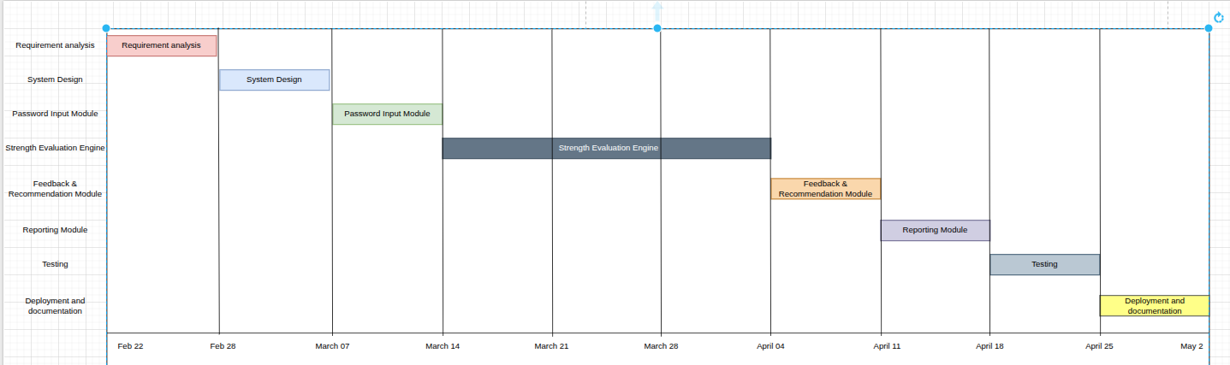
Figure 1: Gantt chart

A well-structured schedule ensures that the Password Strength Analyzer development progresses systematically while maximizing efficiency, meeting deadlines, and delivering a high-quality security tool. By visualizing timelines and resource usage through tools like Gantt charts, the project achieves its objectives in a planned and controlled manner.

Resource Allocation

Efficient resource allocation ensures task ownership and smooth execution:


- Project Manager: Oversees planning, timeline tracking, and overall deliverables.
- System Analyst: Handles requirement gathering and security documentation.
- Security Analyst: Designs password rules, threat models, and strength metrics.
- Front-End Developer: Builds an intuitive interface for password input and feedback visualization.
- Back-End Developer: Implements the strength evaluation engine, APIs, and business logic.
- QA Engineer: Performs comprehensive testing for accuracy, performance, and edge cases.

Risks and Mitigation

Every software project carries risks that may affect progress. For the Password Strength Analyzer, common risks include algorithm inaccuracies, scope creep, and limited security datasets. These are mitigated by:
- Defining clear requirements early to avoid unnecessary feature expansion.
- Validating strength algorithms using known weak-pattern datasets.
- Cross-training team members to handle temporary resource gaps.
- Performing regular code reviews and testing cycles to resolve technical issues early.

Deliverables

Key deliverables for the Password Strength Analyzer project include:

- Requirements Document: Detailed functional and non-functional security requirements.
- System Design Artifacts: Architecture diagrams, flowcharts, and evaluation logic models.
- Functional Password Strength Analyzer: Fully tested and deployed application.
- User Documentation: Guides explaining password scores and improvement suggestions.
- Testing Reports: Recorded results of unit, integration, and system testing.

This structured planning and scheduling approach ensures the Password Strength Analyzer is developed with precision, following the principles of the Waterfall Model. The Gantt chart clarifies timelines, while proactive risk mitigation supports successful delivery of a reliable security solution.



Practical-3
Cost and Effort Estimation for Software Development
Aim: Perform a cost and effort estimation for the selected system by understanding the scope of the software to be developed.

Cost estimation and effort analysis are essential for planning and managing software projects, helping predict the required resources, time, and budget. Function Point Analysis (FPA) is a widely used method to estimate software size, effort, and cost. It measures the functionality delivered to the user, independent of programming languages or technologies. Function points are calculated based on five key components: External Inputs (EI), External Outputs (EO), External Inquiries (EQ), Internal Logical Files (ILF), and External Interface Files (EIF). Each component is assigned a weight based on its complexity (Low, Medium, High), and these are summed up to determine the system's size. This quantitative measure is then used with productivity rates or cost factors to estimate the total effort (in person-hours) and cost of the project, ensuring accurate and standardized planning.

Cost and Effort Estimation
To estimate the cost and effort for developing a Password Strength Analyser using Function Point Analysis (FPA), the following steps can be utilize.

3.1 Understand the Scope of the System

A Password Strength Analyzer typically includes the following modules:

Password Input Module: Securely accepts user passwords for analysis.
Strength Evaluation Engine: Calculates password strength based on length, complexity, entropy, and pattern detection.
Weakness Detection Module: Identifies common issues such as dictionary words, sequences, or repeated characters.
Feedback & Suggestions Module: Provides real-time recommendations to improve password quality.
Authentication (Optional): Login/logout functionality for users if password history or profiles are maintained.



3.2.Identify and Classify Function Types

Function Point Analysis (FPA) for the Password Strength Analyzer involves classifying system components into five elements:
- External Inputs (EI): User-entered passwords and optional configuration settings.
- External Outputs (EO): Password strength score, vulnerability indicators, and improvement suggestions.
- External Inquiries (EQ): User-triggered requests such as “Check Strength” or “View Password Report.”
- Internal Logical Files (ILF): Stored rule sets, strength metrics, pattern libraries, and (if enabled) user history.
- External Interface Files (EIF): External datasets such as breach-pattern libraries or common- password lists used for validation.

Table 3.1: Functionality breakdown

Functionality | Type | Complexity | Count
Password Input | EI | Low | 1
Login/Logout | EI | Low | 1
Password Strength Evaluation | EI | Medium | 3
Strength Check Request | EQ | Medium | 2
Generate Feedback & Suggestions | EO | Medium | 2
View Strength Report | EO | Medium | 1
Rule Set Table | ILF | Low | 1
Password Pattern Table | ILF | Medium | 1
Analysis History Records | ILF | Medium | 1

Table 3.2: Assigning weight for functions

Type | Low | Medium | High
EI | 3 | 4 | 6
EO | 4 | 5 | 7
EQ | 3 | 4 | 6
ILF | 7 | 10 | 15
EIF | 5 | 7 | 10

Calculating Unadjusted Function Points (UFP):


Using the counts and weights above listed in table 3.1 and 3.2. UFP=∑ (Function Count × Weight)

Table 3.3: Function point calculation

Type | Complexity | Count | Weight | Total FP
EI | Low | 2 | 3 | (count*Weight)  6
EI | Medium | 3 | 4 | 12
EQ | Medium | 2 | 4 | 8
EO | Medium | 3 | 5 | 15
ILF | Low | 1 | 7 | 7
ILF | Medium | 2 | 10 | 20  =68

  - Adjust for Complexity Factors

The Value Adjustment Factor (VAF) is applied to the Unadjusted Function Points (UFP) to account for specific technical and operational characteristics of the Password Strength Analyzer. It is derived from 14 General System Characteristics (GSCs), each rated from 0 to 5:

- 0 = No influence on the system.
- 5 = Strong influence on the system.

The formula for calculating the VAF is:

VAF=0.65+(TDI×0.01)

Where TDI (Total Degree of Influence) is the sum of all GSC ratings.

Adjusted Function Points (AFP):
AFP=UFP×VAF



Table 3.4: General System Characteristics for LMS and ratings

No | Characteristic | Description | Rating
1 | Data Communications | Interaction with external datasets (breach patterns, rules) | 3
2 | Distributed Data Processing | Cloud/local processing capability | 2
3 | Performance Requirements | Real-time password analysis | 4
4 | Heavily Used Configuration | Multiple concurrent users | 3
5 | Transaction Rate | Frequent password checks | 4
6 | On-Line Data Entry | Real-time password input | 5
7 | End-User Efficiency | Immediate feedback importance | 4
8 | On-Line Update | Dynamic rule updates | 4
9 | Complex Processing | Entropy + pattern analysis | 4
10 | Re usability | Modular analyzer components | 3
11 | Installation Ease | Simple deployment | 4
12 | Operational Ease | Automated scans & reports | 4
13 | Multiple Sites | Web-based access | 3
14 | Facilitate Change | Easy algorithm upgrades | 3

- TDI (Total Degree of Influence): TDI = 3+2+4+3+4+5+4+4+4+3+4+4+3+3 = 49
- VAF:

VAF =0.65+ (TDI×0.01)

VAF =0.65+ (49×0.01) = 0.65+0.49 = 1.14

AFP

AFP = UFP * VAF

= 68 * 1.14

= 77.52 ≈ 78

Effort Estimation


Effort is estimated based on AFP and the productivity rate. The productivity rate in the context of Function Point Analysis (FPA) refers to the number of Function Points (FPs) that a development team can complete in one Person-Month (i.e., the amount of work one person can complete in a month).

It is an empirical measure based on:

- Team skill level
- Technology used
- Development environment
- Pat project data

Typical Productivity Rates
  - Simple systems: 25–30 FP/Person-Month
  - Moderately complex systems: 15–20 FP/Person-Month
  - Highly complex systems: 7–10 FP/Person-Month

Effort (Person-Months) = AFP / Productivity Rate
For the Password Strength Analyzer, a Productivity Rate of 20 FP / Person-Month is assumed based on:

- Moderately experienced team
- Standard development tools
- Moderate algorithmic complexity

Effort (Person-Months) = AFP / Productivity Rate Approximately, 78 / 20 ≈ 4 Person-Months

Cost Estimation To estimate cost:
Assumed Developer Monthly Cost = 30,000 Rs

Cost Formula:
Cost = Effort × Monthly Cost Cost = 4 × 30,000
Total Cost = 120,000 Rs

(Note: Cost and effort values are approximate and based on assumed parameters.)

Practical 4


Software Requirement Specification (SRS) Development for the Selected System

Aim: Perform a requirement analysis and develop a Software Requirement Specification (SRS) sheet for the selected system. The SRS should include the following sections:

- Functionality: Describe what the software is supposed to do.
- External Interfaces: Explain how the software interacts with people, the system’s hardware, other hardware, and other software.
- Performance: Outline the expected speed, availability, response time, recovery time, and other performance-related characteristics of the software functions.
- Attributes: Design considerations related to portability, correctness, maintainability, security, and other relevant attributes.
- Design Constraints: Specify any design constraints imposed on the implementation, such as required standards, implementation languages, database integrity policies.

Software Requirement Specification (SRS)
A Software Requirement Specification (SRS) is a structured document that defines the functionalities, constraints, and requirements of a software system. It serves as a foundation for development, testing, and stakeholder communication.

Overview
A Password Strength Analyzer is a security-focused software solution designed to evaluate and improve the strength of user passwords. It replaces guesswork and weak password practices with a structured, intelligent analysis system that assesses password complexity, detects vulnerabilities, and provides actionable feedback.

The system enhances security awareness by helping users create stronger passwords, reducing the risk of unauthorized access and Cyber attacks. It provides real-time analysis, improves password quality, and minimizes human errors in password creation.

This Software Requirement Specification (SRS) document follows the IEEE SRS standard and outlines the functional and non-functional requirements of the system, along with external interfaces, constraints, and dependencies.

Purpose
The primary purpose of the Password Strength Analyzer is to provide an automated platform for evaluating password security and guiding users in creating strong, reliable passwords.


The system allows users to input passwords and receive instant feedback on strength, vulnerabilities, and improvement suggestions. It also enables administrators (if applicable) to monitor usage patterns, update security rules, and maintain the effectiveness of the evaluation system.

Additionally, the system may support features such as pattern detection, breach-based validation, and real-time feedback to enhance overall cyber security practices.

Document Conventions
This document follows a structured format using numbered sections, bullet points, and standard technical terminology for clarity and consistency.

It is intended for the following stakeholders:

    - Developers: To understand and implement system functionality and logic.

    - Testers: To validate system performance, accuracy, and reliability.

    - Security Analysts: To define and refine password evaluation rules and threat models.

    - Stakeholders: To review system capabilities, limitations, and overall design.

This document adheres to the IEEE 830-1998 Recommended Practice for Software Requirements Specifications.

Overall Description
This section provides an overview of the system’s purpose, functions, and constraints.

Product Perspective

The Password Strength Analyzer is a standalone security application designed to evaluate and improve password quality. It can function as an independent tool or be integrated into existing systems such as websites, authentication platforms, or enterprise security solutions.

The system replaces weak password practices with a centralized evaluation engine that analyzes password strength using defined rules, entropy calculations, and pattern detection mechanisms.

Product Functions
The system will provide:

- Password Analysis: Evaluate password strength based on length, complexity, entropy, and patterns.
- Weakness Detection: Identify vulnerabilities such as common words, repeated characters, and predictable sequences.
- Real-Time Feedback: Provide instant suggestions to improve password strength.


- Rule Management: Allow updating of security rules and evaluation criteria.
- Reporting & Insights: Display strength scores, feedback, and optional analytics.

Users of the System

- General Users: Individuals who check and improve their password strength.

- Security Analysts: Define rules, patterns, and validation logic.

- System Administrators: Manage deployment, updates, and system maintenance.

General Constraints

- The system must ensure privacy and security, meaning passwords should not be stored in plain text.

- It should provide real-time response with minimal latency.

- The system should be scalable to handle multiple concurrent users.

- It must be compatible with web-based environments and modern browsers.

- The system should operate reliably with high availability.

Specific Requirements
The Specific Requirements section outlines the detailed functional and non-functional needs of the Password Strength Analyzer.

Functional requirements define what the system should do, describing specific operations such as password evaluation and feedback generation. These directly contribute to the core functionality of the system.

Non-functional requirements define how the system performs, focusing on attributes like security, performance, usability, and scalability.

The External Interfaces section describes how the system interacts with users, hardware, and other software systems, ensuring smooth integration and usability.

Functional Requirements

Functional requirements describe what the system should do:

Password Input & Analysis: Accept user passwords and evaluate strength based on defined rules.

Strength Evaluation Engine: Calculate password strength using entropy, character diversity, and pattern detection.


Weakness Detection: Identify common vulnerabilities such as dictionary words, repeated patterns, and predictable sequences.

Feedback & Suggestions: Provide real-time recommendations to improve password strength. Pattern Recognition: Detect commonly used password structures and unsafe formats.
Reporting & Insights: Display strength scores, analysis results, and improvement suggestions.

Optional User Authentication: Allow users to log in and track password improvement history (if implemented).

External Interfaces

External interfaces define how the system interacts with users, hardware, and other software components:

User Interface (UI):

A web-based interface that allows users to input passwords and receive real-time feedback in an intuitive manner.

Hardware Interface:

The system should be accessible on desktops, laptops, and mobile devices without requiring specialized hardware.

Software Interfaces:

The system may integrate with databases (SQL/NoSQL) for storing rules, patterns, or optional user history.

Communication Interfaces:

The system may support API-based communication for integration with external applications such as login systems or security platforms.

Non-Functional Requirements

Non-functional requirements define system quality attributes:

Performance:

The system should provide real-time analysis with response time under 2 seconds.

Security:


Passwords must not be stored in plain text. Encryption and secure handling must be implemented.

Usability:

The interface should be simple, responsive, and easy to use for all types of users.

Scalability:

The system must support increasing numbers of users without performance degradation.

Availability:

The system should ensure high uptime and reliability with minimal downtime.

Design Constraints
Design constraints define limitations affecting implementation:
Technology Stack:
The system should be developed using technologies such as Node.js (backend), React.js (frontend), and MongoDB or SQL databases.
Security Compliance:
The system must ensure secure password handling and follow best practices for data protection.

Performance Optimization:
Efficient algorithms should be used for fast password evaluation and minimal latency.

Deployment Environment:
The system should support web-based deployment and optional cloud hosting.

System Attributes
Portability:
The system should run on Windows, macOS, Linux, and mobile browsers.

Maintainability:
Modular architecture to allow easy updates to rules and algorithms.

Reliability:
Consistent and accurate password evaluation with minimal failure.

Scalability:
Capable of handling growth in users and analysis requests efficiently.

Interoperability:
Ability to integrate with authentication systems and third-party security tools.


Extensibility:
The system should support future enhancements like AI-based analysis or breach detection.

4.4.6 Implementation details and Hardware Requirements

This section defines the implementation approach and required hardware specifications for the Password Strength Analyzer.

Implementation Details

The Password Strength Analyzer is implemented as a web-based application to ensure accessibility and ease of deployment.

- Frontend: Developed using React.js (or standard HTML, CSS, JavaScript) to provide a responsive and interactive user interface.

- Backend: Built using Node.js to handle password evaluation logic, rule processing, and API communication.

- Database (Optional): MongoDB or SQL database used to store rule sets, pattern libraries, and optional user analysis history.

- Core Logic:

Password strength calculated using entropy, length, and character diversity.

Pattern detection implemented using rule-based checks (dictionary words, sequences, repetitions). Real-time feedback generated dynamically as the user types.

- Security Measures:

Passwords are processed in-memory and not stored in plain text. Optional hashing can be applied if temporary storage is required.

Hardware Requirements

The system is lightweight and does not require high-end hardware.



Minimum Requirements:

- Processor: Dual-core CPU (Intel i3 or equivalent)

- RAM: 4 GB

- Storage: 100 MB free space

- Internet: Required for web-based access

Practical 5


System Analysis and Design for the Selected System
Aim: Perform system analysis on selected system. 1)Systems analysis (what the system should do)
2) Systems design (how to accomplish the objective of the system.) (Hint: Flowcharts/ER diagrams)

System Analysis and Design
The Password Strength Analyzer is a security-focused software solution designed to evaluate and improve password strength by analyzing complexity, detecting vulnerabilities, and providing actionable feedback. The system enhances cybersecurity awareness, reduces risks associated with weak passwords, and improves overall user safety.

System Analysis
The Password Strength Analyzer aims to achieve the following objectives:

- Effective Password Evaluation: Accurately analyze password strength using entropy, length, and character diversity.

- Real-Time Analysis: Provide instant feedback while users type passwords.

- Security Enhancement: Help users avoid weak passwords and common attack patterns.

- User Guidance: Offer actionable suggestions to improve password strength.

- Pattern Detection: Identify common vulnerabilities such as dictionary words, sequences, and repeated characters.

- Scalability: Support a growing number of users and requests without performance degradation.

Gather System Requirements

Functional Requirements :The system includes a Password Input Module, allowing users to enter passwords for analysis.

The Strength Evaluation Module processes the password using entropy calculations, character diversity checks, and rule-based logic to determine its strength.

The Weakness Detection Module identifies vulnerabilities such as dictionary words, predictable sequences (e.g., “12345”), and repeated patterns.

The Feedback and Recommendation Module provides real-time suggestions to improve password strength, such as adding symbols, increasing length, or avoiding common patterns.


The Pattern Recognition Module analyzes the structure of passwords to detect commonly used formats and unsafe habits.

An optional User Account Module may allow users to store analysis history and track improvements over time.

The system also incorporates Security Measures, ensuring that passwords are not stored in plain text and are processed securely.

Non Functional Requirements:

- Performance: The system should provide real-time analysis with response times under 2 seconds.

- Scalability: The system must handle increasing numbers of users efficiently without affecting performance.

- Usability: The interface should be simple, intuitive, and user-friendly.

- Security: Sensitive data must be handled securely, with no storage of plain-text passwords.

- Maintainability: The system should be modular, allowing easy updates to rules and algorithms.

- Reliability: The system must provide consistent and accurate results without failure.

Analyze the Current System Existing Issues
Current password practices rely heavily on user intuition, which often leads to weak and predictable passwords. Many users reuse simple passwords, include personal information, or follow common patterns, making them vulnerable to attacks.

There is a lack of real-time feedback during password creation, resulting in users unknowingly choosing insecure passwords. Additionally, existing systems often do not provide detailed explanations or actionable suggestions for improvement.

Without proper analysis tools, users remain unaware of how easily their passwords can be compromised.

Gaps Identified

To improve password security, the following gaps must be addressed:

      - A real-time analysis system is required to evaluate password strength instantly.


      - Advanced pattern detection is needed to identify weak structures and common attack patterns.

      - User guidance mechanisms must be implemented to suggest improvements.

      - Privacy-focused processing is essential to ensure passwords are not stored or exposed.

      - A reporting mechanism is useful to provide insights into password strength and vulnerabilities.

System Design
System Design defines the architecture, modules, interfaces, and data flow required to meet system requirements.

For the Password Strength Analyzer, this phase transforms functional requirements into a structured design that ensures efficiency, scalability, and security. The system is designed to deliver fast, accurate, and secure password analysis.

Architectural Design

The Password Strength Analyzer follows a three-tier architecture:

Presentation Layer: A web-based user interface where users input passwords and receive real-time feedback.

Business Logic Layer: Handles core functionalities such as strength evaluation, entropy calculation, pattern detection, and feedback generation.

Database Layer (Optional): Stores rule sets, pattern libraries, and optional user analysis history.

User Interface Design

The user interface (UI) is designed to be simple, interactive, and user-friendly, focusing on real- time feedback and clarity.

Key UI components include:

      - Password Input Screen: A secure input field where users type passwords and instantly receive strength feedback.

      - Strength Indicator: Visual representation (e.g., weak, medium, strong) using colors or progress bars.

      - Feedback Panel: Displays suggestions such as “Add special characters” or “Increase length.”

      - Analysis Details Section: Shows detected weaknesses like repeated characters, dictionary matches, or predictable patterns.


      - Optional User Dashboard: Allows users to view past password analysis (if authentication is implemented).

      - Real-Time Notification System: Provides instant alerts while typing, highlighting weak parts of the password.

Module Description Password Input Module
This module allows users to securely enter passwords for analysis. It ensures safe handling of input data without storing passwords in plain text. Real-time capture of input enables instant feedback.

Strength Evaluation Module

This is the core module responsible for analyzing password strength. It evaluates parameters such as length, character diversity (uppercase, lowercase, numbers, symbols), and entropy to generate a strength score.

Weakness Detection Module

This module identifies vulnerabilities in passwords, such as dictionary words, repeated characters, common patterns (e.g., “12345”, “password”), and predictable structures.

Feedback & Recommendation Module

Based on analysis results, this module provides actionable suggestions to improve password strength, such as increasing length, adding symbols, or avoiding common patterns.

Pattern Recognition Module

This module detects commonly used password structures and unsafe habits (e.g., “Name@123”). It helps identify structural weaknesses beyond simple rule checks.

Reporting & Visualization Module

Displays password strength scores, detected weaknesses, and improvement suggestions. It may include visual indicators such as strength bars or ratings.

Optional User Management Module

If implemented, this module allows users to create accounts and track password strength history over time. It includes authentication and basic profile management.

Database Design and ER diagram

The database design for the Password Strength Analyzer is structured to efficiently manage rule sets, pattern libraries, and optional user data. The system prioritizes privacy, ensuring that raw passwords are not stored.


The database follows a relational or NoSQL model, depending on implementation needs, ensuring efficient data retrieval and scalability.

Entities and Relationships:

User (User_ID, Email, Role, Password_Hash)

- Represents registered users (if authentication is enabled).

- A user can perform multiple password analyses.

Password Analysis (Analysis_ID, User_ID, Strength_Score, Timestamp)
- Stores results of password evaluations (without storing actual passwords).
- Links to the user (optional).

Rule Set (Rule_ID, Rule_Name, Description, Weight)
- Defines evaluation rules such as minimum length, character requirements, etc.
- Used by the evaluation engine.

Pattern Library (Pattern_ID, Pattern_Type, Description)
- Contains common weak patterns (e.g., sequences, dictionary words).
- Used for vulnerability detection.

Feedback (Feedback_ID, Analysis_ID, Suggestion)

- Stores generated suggestions for improving password strength.

Relationship Summary

- A User can have multiple Password Analyses.
- Each Password Analysis generates multiple Feedback entries.
- The Rule Set and Pattern Library are referenced during analysis but remain independent entities.

Figure 5.1 ER Diagram


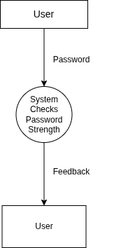
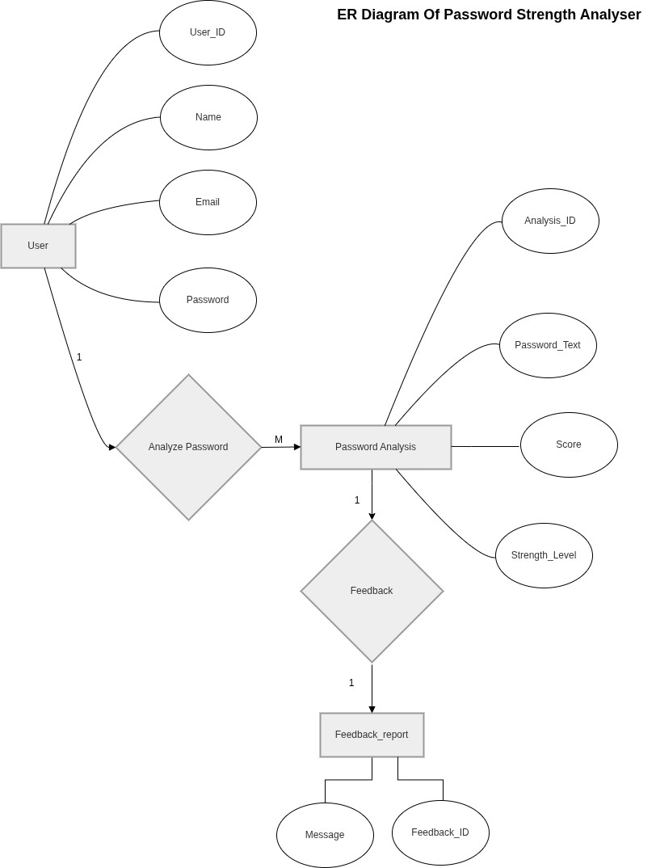

Figure 5.2 Data Flow Diagram



Figure 5.3 System Architecture Diagram
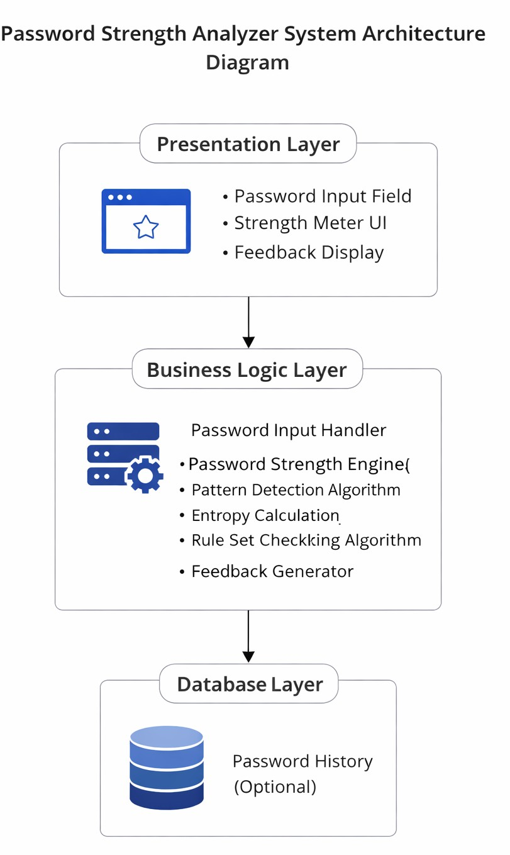

Conceptual ER diagram symbols
Conceptual Data Models establish a broad view of what should be included in the model set. Conceptual ERDs can be used as the foundation for logical data models. They may also be used to form commonality relationships between ER models as a basis for data model integration. All of the symbols

shown below are found in the UML Entity Relationship and Entity Relationship shape library of Lucidchart.

ERD entity symbols

Entities are objects or concepts that represent important data. Entities are typically nouns such as product, customer, location, or promotion. There are three types of entities commonly used in entity relationship diagrams.

Entity Symbol Name Description

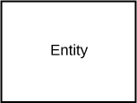
Strong entity
These shapes are independent from other entities, and are often called parent entities, since they will often have weak entities that depend on them. They will also have a primary key, distinguishing each occurrence of the entity.

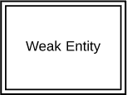
Weak entity

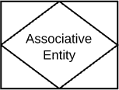
Associative entity
Weak entities depend on some other entity type. They don't have primary keys, and have no meaning in the diagram without their parent entity.

Associative entities relate the instances of several entity types. They also contain attributes specific to the relationship between those entity instances.



ERD relationship symbols

Within entity-relationship diagrams, relationships are used to document the interaction between two entities. Relationships are usually verbs such as assign, associate, or track and provide useful information that could not be discerned with just the entity types.

Relationship Symbol Name Description

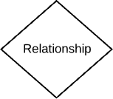
Relationship Relationships are associations
between or among entities.

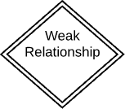
Weak relationship
Weak Relationships are connections between a weak entity and its owner.



ERD attribute symbols

ERD attributes are characteristics of the entity that help users to better understand the database. Attributes are included to include details of the various entities that are highlighted in a conceptual ER diagram.

Attribute Symbol Name Description

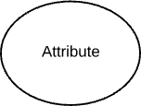
Attribute

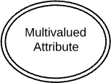
Multivalued attribute

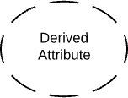
Derived attribute
Attributes are characteristics of an entity, a many-to-many relationship, or a one-to-one relationship.

Multivalued attributes are those that are can take on more than one value.

Derived attributes are attributes whose value can be calculated from related attribute values.




Relationship Relationships are associations
between or among entities.

Want to make an ERD of your own? Try Lucidchart. It's quick, easy, and completely free.
Make an ERD


Physical ER diagram symbols
The physical data model is the most granular level of entity-relationship diagrams, and represents the process of adding information to the database. Physical ER models show all table structures, including column name, column data type, column constraints, primary key, foreign key, and relationships between tables.
As shown below, tables are another way of representing entities. The key parts of Entity-relationship Tables are:

Fields

Fields represent the portion of a table that establish the attributes of the entity. Attributes are typically thought of as columns in the database that the ERD models.
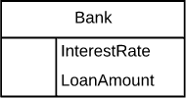
In the image above, InterestRate and LoanAmount are both attributes of the entity that are contained as fields.

Keys

Keys are one way to categorize attributes. ER diagrams help users to model their databases by using various tables that ensure that the database is organized, efficient, and fast. Keys are used to link various tables in a database to each other in the most efficient way possible.
Primary Keys
Primary keys are an attribute or combination of attributes that uniquely identifies one and only one instance of an entity.
Foreign Keys
Foreign keys are created any time an attribute relates to another entity in a one-to-one or one-to-many relationship.
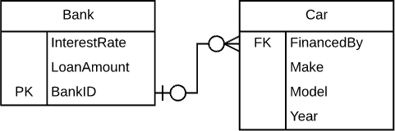


Each car can only be financed by one bank, therefore the primary key BankId from the Bank table is used as the foreign key FinancedBy in the Car table. This BankID is able to be used as the foreign key for multiple cars.

Types

Types refer to the type of data in the corresponding field in a table. Types can also refer to entity types, which describe the composition of an entity; e.g., a book's entity types are author, title, and published date.
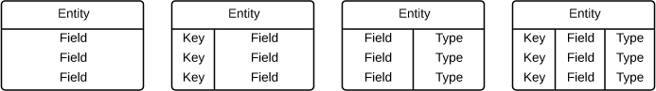

ER diagram notation
While crow's foot notation is often recognized as the most intuitive style, some use OMT, IDEF, Bachman, or UML notation, according to their preferences. Crow's foot notation, however, has an intuitive graphic format, making it the preferred ERD notation for Lucidchart. Consider using one of our Crow Foot ER Diagram templates.

Cardinality and ordinality

Cardinality refers to the maximum number of times an instance in one entity can relate to instances of another entity. Ordinality, on the other hand, is the minimum number of times an instance in one entity can be associated with an instance in the related entity.
Cardinality and ordinality are shown by the styling of a line and its endpoint, according to the chosen notation style.


Practical 6

User’s view Analysis

Aim: Perform the user's view analysis for the suggested system by drawing Use case Diagram.

User View Analysis

User’s view analysis is the process of understanding the interactions of different users with the system. It helps in identifying the functionalities required by different users and ensures that the system meets their needs effectively.

Purpose of Use-Case:
The Use case diagram is used to gather the requirements of a system. It is used to get an out side view of a system. It Identifies the external and internal factors influencing the system. It is also used to show the interaction among the requirements.

  - Notations of Use-Case:

Notation Description | Visual Representation
Actor
- Someone interacts with use case (system function).
- Named by noun.
- Actor plays a role in the business
- Similar to the concept of user, but a user can play different roles.
Use Case
System function(process-automated or manual) Named by verb+ Noun(or Noun Phrase).
Communication Link
The participation of an actor in a use case is shown by connecting an actor to a use-case by a solid link. Actors may be connected to use cases by associations, indicating that the actor and the use-case communicate


with one another using messages.

Boundary of system
- The system boundary is potentially the entire system as defined in the requirements document. For large and complex systems,
each module may be the system boundary.
Extends  - Example: Indicates that an "Invalid- Password" use case may include the behavior specified by base use case "Login Account".  - Depict with a directed arrow having a dotted line. The tip of arrow head points to the base use case and the child use case is connected at the base of the arrow. The stereotype"<<extends>>"identifies as an extend relationship | 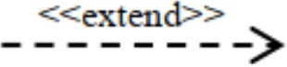
Include  - When a use case is depicted as using the functionality of another use case, the relationship between the use cases is named as include or uses relationship.  - A use case includes the functionality described in another use case as a part of its business process flow. Thestereotype"<<include>>"identifiestherela tionshipasanincluderelationship. | 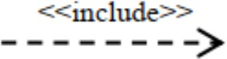
Generalization

1 A generalization relationship is a parent-child relationship between use cases.



6.3 User’s View Analysis for Library Management System
User’s view analysis is the process of understanding how different users interact with the Password Strength Analyzer. It helps identify the functionalities required by each user type and ensures the system effectively meets their needs.

Actors in the System

An actor is an entity that interacts with the system. The Password Strength Analyzer includes the following actors:

- General User

  - Enters passwords to check their strength.

  - Receives real-time feedback and suggestions.

  - Improves password quality based on recommendations.

  - (Optional) Views previous password analysis history.

- Security Analyst

  - Defines password strength rules and evaluation criteria.

  - Updates pattern detection logic (e.g., common passwords, sequences).

  - Monitors effectiveness of strength evaluation algorithms.

  - Enhances system security measures over time.

- System Administrator

  - Oversees system operations and deployment.

  - Manages system configurations and updates.

  - Monitors system usage and performance.

  - Maintains optional user data and system logs.

Use Cases

A use case represents a specific function performed by an actor within the system.


For General Users:
    - Enter Password – Input a password for analysis.
    - Check Password Strength – View strength score (weak/medium/strong).
    - View Feedback – Receive suggestions to improve password security.
    - Improve Password – Modify password based on recommendations.
    - View Analysis History (Optional) – Check past password evaluations.
For Security Analysts:
    - Define Rules – Set criteria for password strength evaluation.
    - Update Pattern Library – Add or modify known weak patterns.
    - Tune Algorithms – Improve entropy calculations and detection logic.
For System Administrators:

- Manage System Configuration – Configure backend settings and deployment.
- Monitor System Usage – Track system activity and performance.
- Maintain System Data – Manage optional password history and logs.
Figure 1: use case diagram
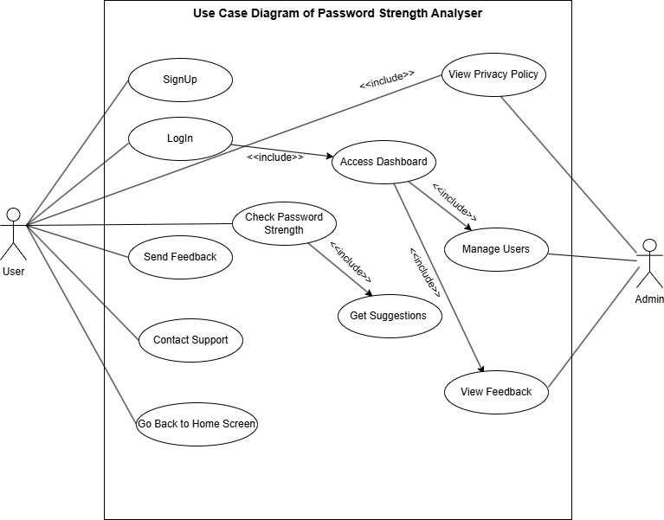

Practical 7

Structural View Diagram

Aim: To Design structural view diagram for the selected system using class Diagram, Object Diagram, and Component Diagram.

Structural View Diagrams
Structure diagrams depict the static structure of the elements in your system. i.e., how one object relates to another.It shows the things in the system – classes, objects, packages or modules, physical nodes, components, and interfaces. Since structure diagrams represent the structure, they are used extensively in documenting the software architecture of software systems. The Seven UML structural diagrams are roughly organized around the major groups of things you’ll find when modeling a system. Since structure diagrams represent the structure, they are used extensively in documenting the software architecture of software systems.

Table 7.1:Structural View Diagram

Structural Diagram Brief Description

Composite Structure Diagram
It shows the internal structure of a classifier, classifier interactions with the environment through ports, or behavior of a collaboration.


Deployment Diagram It shows a set of nodes and their relationships that
illustrates the static deployment view of an architecture.
Package Diagram It groups related UML elements into a collection of
logically related UML structure.
Class Diagram It shows a set of classes, interfaces, and collaborations
and their relationships, typically, found in modeling object-oriented systems.
Object Diagram It shows a set of objects and their relationships, which
is the static snapshots of instances of the things found in class diagrams.
Component Diagram It shows a set of components and their relationships
that illustrates the static implementation view of a system.


Class Diagram
The UML Class diagram is a graphical notation used to construct and visualize object oriented systems. A class diagram in the Unified Modeling Language (UML) is a type of static structure diagram that describes the structure of a system by showing the system's:
classes,
their attributes, operations (or methods),
and the relationships among objects.
Purpose of Class diagram:
      - Class diagram is a static diagram.
      - It represents the static view of an application.
      - Class diagram is not only used for visualizing, describing, and documenting different aspects of a system but also for constructing executable code of the software application.

Notations Class Notation
A class notation consists of three parts:

Class Name
  - The name of the class appears in the first partition.

Class Attributes
  - Attributes are shown in the second partition.
  - The attribute type is shown after the colon.
  - Attributes map onto member variables (data members) in code.
- Class Operations (Methods)
  - Operations are shown in the third partition. They are services the class provides.
  - The return type of a method is shown after the colon at the end of the method signature.
  - The return type of method parameters is shown after the colon following the parameter name.
  - Operations map onto class methods in code 3.12
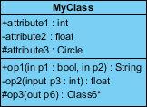

The graphical representation of the class - MyClass as shown above:
- MyClass has 3 attributes and 3 operations


- Parameter p3 of op2 is of type int
- op2 returns a float
- op3 returns a pointer (denoted by a *) to Class6

Class Relationships
A class may be involved in one or more relationships with other classes. A relationship can be one of the following types: (Refer to the figure on the right for the graphical representation of relationships).

Inheritance (or Generalization):

- Represents an "is-a" relationship.
- An abstract class name is shown in italics.
- SubClass1 and SubClass2 are specializations of Super Class.
- A solid line with a hollow arrowhead that point from the child to the parent class

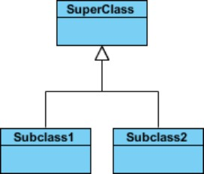

Simple Association:
  - A structural link between two peer classes.
  - There is an association between Class1 and Class2
  - A solid line connecting two classes
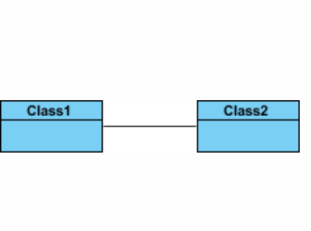



Aggregation:
A special type of association. It represents a "part of" relationship.
- Class2 is part of Class1.
- Many instances (denoted by the *) of Class2 can be associated with Class1.
- Objects of Class1 and Class2 have separate lifetimes.
- A solid line with an unfilled diamond at the association end connected to the class of composite
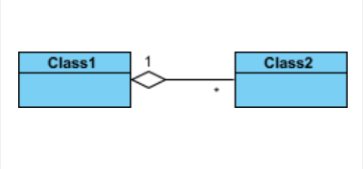

Composition:
A special type of aggregation where parts are destroyed when the whole is destroyed.
- Objects of Class2 live and die with Class1.
- Class2 cannot stand by itself.
- A solid line with a filled diamond at the association connected to the class of composite.
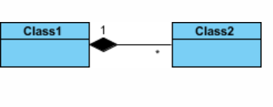

Dependency:
- Exists between two classes if the changes to the definition of one may cause changes to the other (but not the other way around).
- Class1 depends on Class2
- A dashed line with an open arrow Multiplicity
How many objects of each class take part in the relationships and multiplicity can be expressed as:
- Exactly one - 1
- Zero or one - 0..1
- Many - 0..* or *
- One or more - 1..*


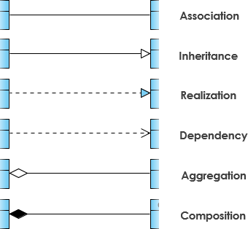

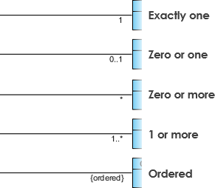


Class Diagram
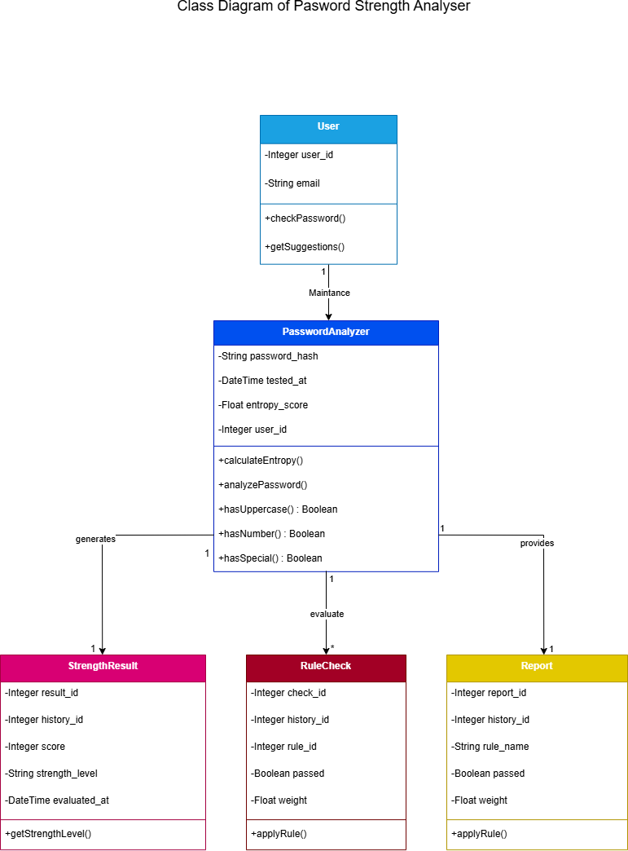
Figure 7.1 class diagram


Object Diagram
Object diagrams are a visual representation in UML (Unified Modeling Language) that illustrates the instances of classes and their relationships within a system at a specific point in time. They display objects, their attributes, and the links between them, providing a snapshot of the system’s structure during execution.

An object diagram in UML is useful because it provides a clear and visual representation of specific instances of classes and their relationships at a particular point in time, aiding in understanding and communicating the structure and interactions within a system.

Object Diagram Notations
The object diagram in UML uses specific notations to represent instances of classes and their relationships at a particular moment in time.
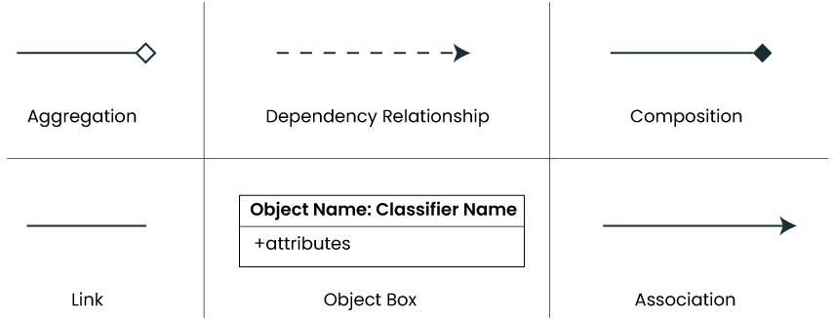

- Objects or Instance specifications
When we instantiate a classifier in a system, the object we create represents an entity which exists in the system. We can represent the changes in object over time by creating multiple instance specifications. We use a rectangle to represent an object in an object diagram

- Attributes and Values
Inside the object box, attributes of the object are listed along with their specific values.


Object Diagram

An Object diagram showing password analysis
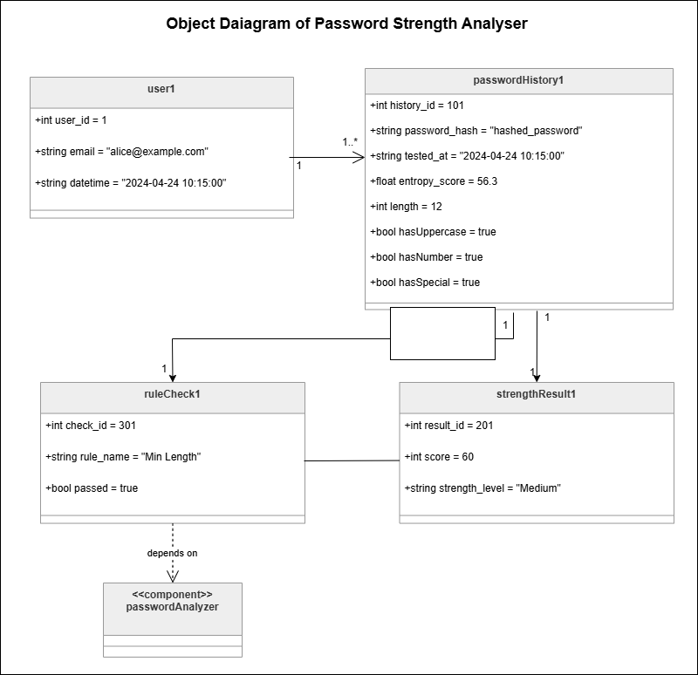

Component Diagram

Component-based diagrams are essential tools in software engineering, providing a visual representation of a system’s structure by showcasing its various components and their interactions. These diagrams simplify complex systems, making it easier for developers to design, understand, and communicate the architecture
.


Components of Component-Based Diagram

- Component
Represent modular parts of the system that encapsulate functionalities. Components can be software classes, collections of classes, or subsystems.
Symbol: Rectangles with the component stereotype («component»). Function: Define and encapsulate functionality, ensuring modularity and reusability.
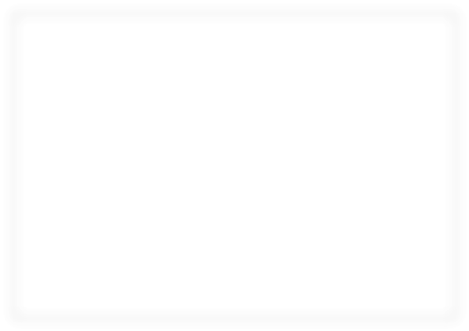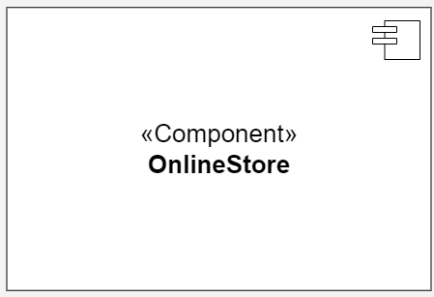

- Interfaces
Specify a set of operations that a component offers or requires, serving as a contract between the component and its environment.
Symbol: Circles (lollipops) for provided interfaces and half-circles (sockets) for required interfaces.
Function: Define how components communicate with each other, ensuring that components can be developed and maintained independent.


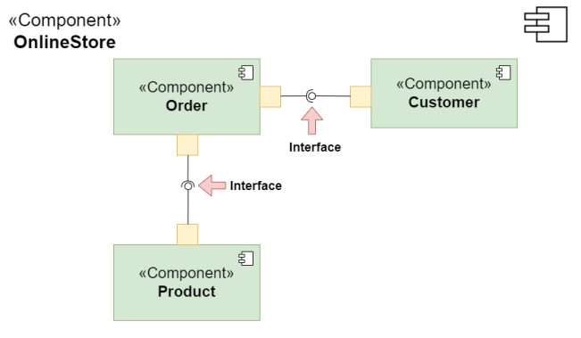



- Relationships

Depict the connections and dependencies between components and interfaces.
- Symbol: Lines and arrows.
-Dependency (dashed arrow): Indicates that one component relies on another.
-Association (solid line): Shows a more permanent relationship between components.
-Assembly connector: Connects a required interface of one component to a provided interface of another.
- Function: Visualize how components interact and depend on each other, highlighting communication paths and potential points of failure.

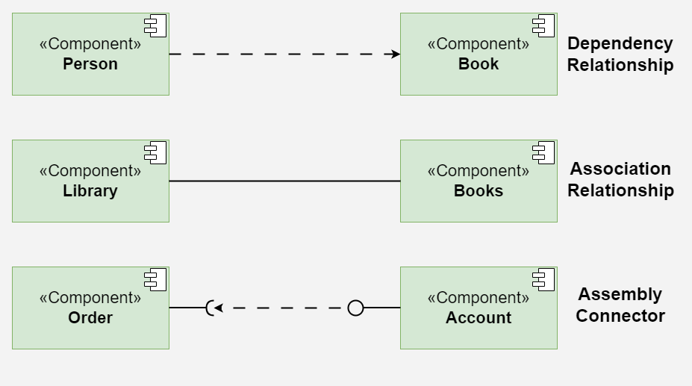

- Ports

Role: Represent specific interaction points on the boundary of a component where interfaces are provided or required.
Symbol: Small squares on the component boundary.
Function: Allow for more precise specification of interaction points, facilitating detailed design and implementation.
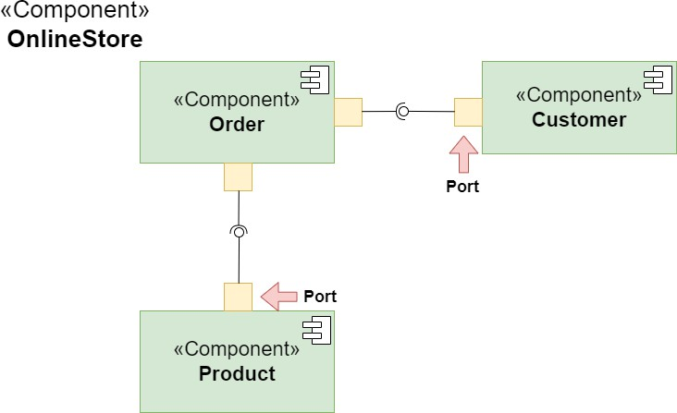



- Artifacts

Represent physical files or data that are deployed on nodes.
Symbol: Rectangles with the artifact stereotype («artifact»).
Function: Show how software artifacts, like executables or data files, relate to the components.


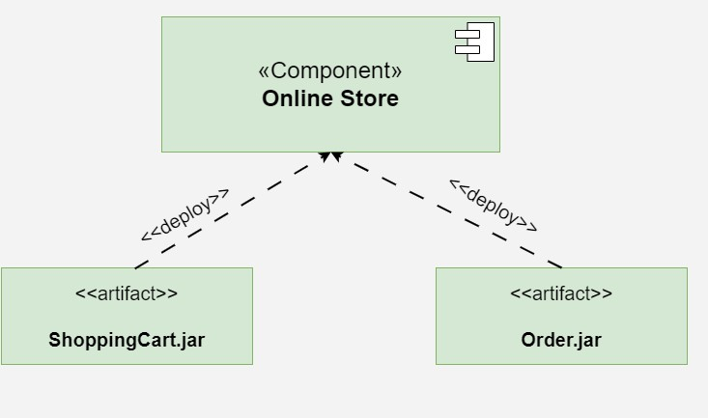

- Nodes

Represent physical or virtual execution environments where components are deployed.
Symbol: 3D boxes.
Function: Provide context for deployment, showing where components reside and execute within the system’s infrastructure.

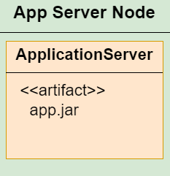

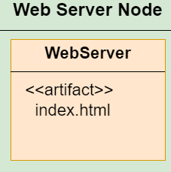



    - Component Diagram
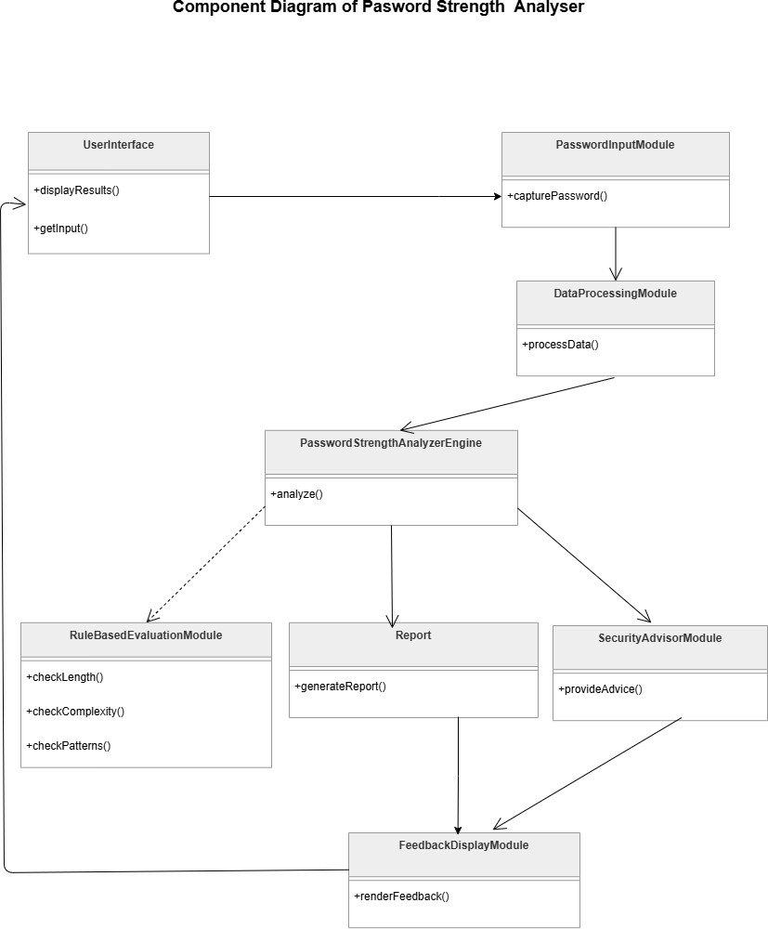



Practical 8

Function -Oriented diagram
Aim: Design function-oriented diagram for the selected system using Data Flow Diagrams

8.1 Data Flow Diagrams(DFD)

Purpose of Data Flow Diagrams:
A data flow diagram (DFD) maps out the flow of information for any processor system. It uses defined symbols like rectangles, circles and arrows, plus short text labels, to show data inputs, outputs, storage points and the routes between each destination.

Notations of Data Flow Diagrams:
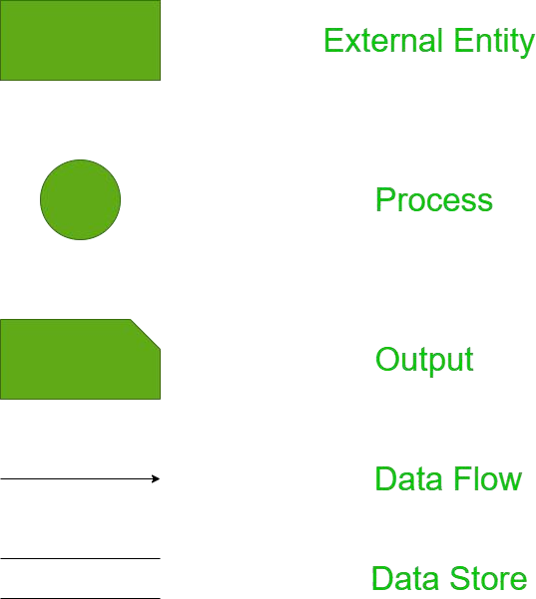



      - Entities:
        - Entities include source and destination of the data. Entities are represented by
rectangle with their corresponding names.
      - Process:
        - The tasks performed on the data is known as process. Process is represented by circle.
Somewhere round edge rectangles are also used to represent process.

      - Data Storage:
- Data storage includes the database of the system. It is represented by rectangle with both smaller sides missing or in other words within two parallel lines.
- Data Flow:
  - The movement of data in the system is known as dataflow. It is represented with the help
of arrow. The tail of the arrow is source and the head of the arrow is destination.

Levels of Data Flow Diagrams:
      - In Software engineering DFD (data flow diagram) can be drawn to represent the system of different levels of abstraction. Higher-level DFDs are partitioned into low levels-hacking more information and functional elements. Levels in DFD are numbered 0, 1, 2or beyond.
Here, we will see mainly 3 levels in the data flow diagram, which are:0-level DFD,1-level DFD, and2-levelDFD.

- 0-level DFD:
  - It is also known as a context diagram. It’s designed to be an abstraction view, showing the system as a single process with its relationship to external entities. It represents the entire system as a single bubble within put and output data indicated by incoming/outgoing arrows.

- 1-level DFD:
  - In 1-level DFD, the context diagram is decomposed into multiple bubbles/processes. In this level, we highlight the main functions of the system and breakdown thehigh- levelprocessof0-levelDFDinto sub processes.

- 2-level DFD:
  - 2-level DFD goes one step deeper into parts of 1-level DFD. It can be used to plan or record the specific/necessary detail about the system’s functioning.



DFD of Password Strength Analyzer

Level 0(Context level diagram )
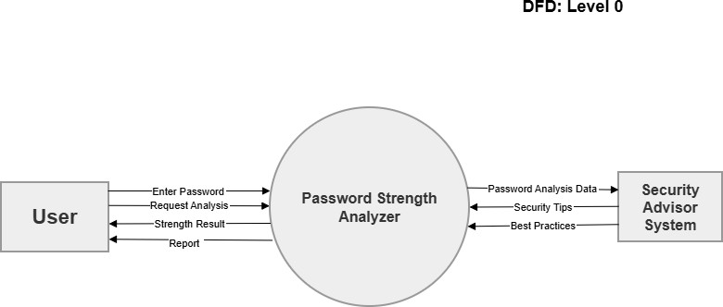

Figure 8.1 Level 0 DFD

Level 1 DFD
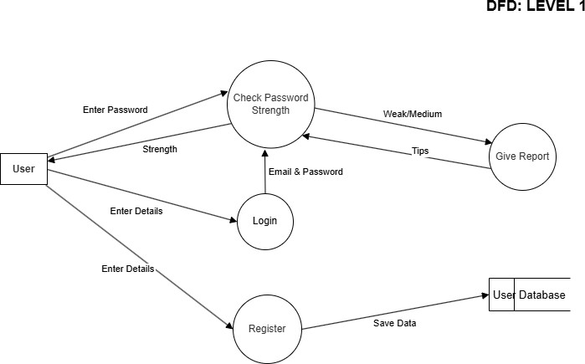


Practical 9

Behavioral View diagram

Aim: Design the behavioral view diagram for the selected system. Use following diagrams

- Interaction Diagrams a. Sequence Diagrams b. Collaboration Diagram

- State–Chart Diagrams

- Activity Diagrams

Behavioral diagrams are used to visualize, specify, construct, and document the dynamic aspects of a system. It shows how the system behaves and interacts with itself and other entities (users, other systems). They show how data moves through the system, how objects communicate with each other, how the passage of time affects the system, or what events cause the system to change internal states. Since behavior diagrams illustrate the behavior of a system, they are used extensively to describe the functionality of software systems. As an example, the activity diagram describes the business and operational step-by-step activities of the components in a system. In other words, a behavioral diagram shows how the system works ‘in motion’, that is how the system interacts with external entities and users, how it responds to input or event and what constraints it operates under.

Interaction Diagrams

The purpose of interaction diagrams is to visualize the interactive behavior of the system Sequence and collaboration diagrams are used to capture the dynamic nature but from a different angle.

Terminology of Interaction diagram:
- An interaction diagram contains lifelines, messages, operators, state invariants and constraints.
Lifeline

A lifeline represents a single participant in an interaction. It describes how an instance of a specific classifier participates in the interaction. A life line represents a role that an instance of the classifier may play in the interaction.
Various attributes of a lifeline,

Name
- It is used to refer to the life line within a specific interaction.
- The name of a life line is optional.

- Type
- It is the name of a classifier of which the life line represents an instance.
- Selector
- It is a Boolean condition which is used to select a particular instance that satisfies the requirement.
- Select or attribute is also optional.

Messages

A message is a specific type of communication between two lifelines in an interaction. A message involves following activities
A call message which is used to call an operation. A message to create an instance.
A message to destroy an instance. For sending a signal.

Message Type Description Example

Synchronous Sender waits for receiver to complete before continuing
Asynchronous Sender continues without waiting for
response
Return Represents return of control or data from
receiver to sender
objectA.method() sendMessage() return value

Create Indicates creation of a new object new Object() Delete Indicates termination of an object object.destroy() Self-Message An object sends a message to itself this.doSomething()

Found Message
Message originates outside the system or is unidentified
External API call

Lost Message Message is sent but the destination is
unknown or not modeled
Log message not saved



State in variants and constraints

- When an instance or a lifeline receives a message, it can cause it to change the state.
- A state is a condition or a situation during a life time of an object at which it satisfies some constraint, performs some operations, and waits for some event.
- In an interaction diagram, not all messages cause changes to change the state of an instance.

Some messages donot have the values of some attributes. It has no side effects on the state of an object.

Operator
An operator specifies an operation on how the operands are going to be executed.
- The operators in UML support operations on data in the form of branching as well as an iteration. Various operators can be used to ensure the use of iteration and branching in the UML model.


Iteration
    - In an interaction diagram, we can also show iteration using an iteration expression.
    - An iteration expression consists of an iteration specifier and an optional iteration clause. There is no pre-specified syntax for UML iteration.

Branching
    - In an interaction diagram, we can represent branching by adding guard conditions to the messages. Guard conditions are used to check if a message can be sent forward or not.
    - A message is sent forward only when its guard condition is true.
    - A message can have multiple guard conditions, or multiple messages can have the same guard condition.
    - Branching in UML is achieved with the help of alt and opt, operators.

Types of Interaction diagram:
  - Different types of interaction diagrams defined in UML:
  - Sequence diagram
  - Collaboration diagram
  - Timing diagram

Sequence diagram

Sequence Diagrams are interaction diagrams that detail how operations are carried out. They capture the interaction between objects in the context of a collaboration. Sequence Diagrams are time focus and they show the order of the interaction visually by using the vertical axis of the diagram to represent time what messages are sent and when.

Purpose of Sequence Diagram
- Model high-level interaction between active objects in a system
- Model the interaction between object instances within a collaboration that realizes a use case
- Model the interaction between objects within a collaboration that realizes an operation
- Either model generic interactions (showing all possible paths through the interaction) or specific instances of a interaction (showing just one path through the interaction)

Sequence Diagram Notation

Notation Symbol
Actor
- A type of role played by an entity that interacts with the subject (e.g., by exchanging signals and data)
- External to the subject (i.e., in the sense that an instance of an actor is not a part of the instance of its corresponding subject).
- Represent roles played by human users, external hardware, or other subjects.

Lifeline

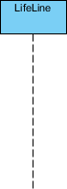
- A lifeline represents an individual participant in the Interaction.



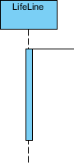
Activations
  - A thin rectangle on a lifeline) represents the period during which an element is performing
an operation.
  - The top and the bottom of the of the rectangle are aligned with the initiation and the completion
time respectively



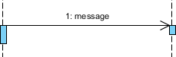
Call Message
  - A message defines a particular communication between Lifelines of an Interaction.
  - Call message is a kind of message that represents an invocation of operation of target
lifeline.

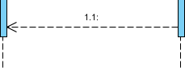
Return Message
  - A message defines a particular communication between Lifelines of an Interaction.
  - Return message is a kind of message that represents the pass of information back to the caller
of a corresponded former message.

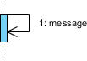
Self Message
- A message defines a particular communication between Lifelines of an Interaction.
- Self message is a kind of message that represents the invocation of message of the same lifeline.

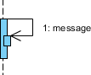
Recursive Message
- A message defines a particular communication between Lifelines of an Interaction.
- Recursive message is a kind of message that represents the invocation of message of the same
lifeline. It's target points to an activation on top of the activation where the message was invoked from.



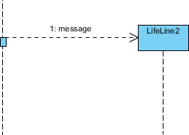
Create Message
- A message defines a particular communication between Lifelines of an Interaction.
- Create message is a kind of message that represents the instantiation of (target) lifeline.

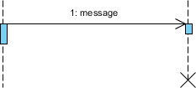
Destroy Message
  - A message defines a particular communication between Lifelines of an Interaction.
  - Destroy message is a kind of message that represents the request of destroying the lifecycle of target lifeline.

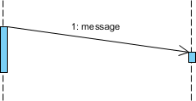
Duration Message
  - A message defines a particular communication between Lifelines of an Interaction.
  - Duration message shows the distance between two time instants for a message invocation.


Note
A note (comment) gives the ability to attach various remarks to elements. A comment carries no semantic force, but may contain information that is useful to a modeler.

Message and Focus of Control
- An Event is any point in an interaction where something occurs.
- Focus of control: also called execution occurrence, an execution occurrence
- It shows as tall, thin rectangle on a lifeline)
- It represents the period during which an element is performing an operation. The top and the bottom of the rectangle are aligned with the initiation and the completion time respectively.



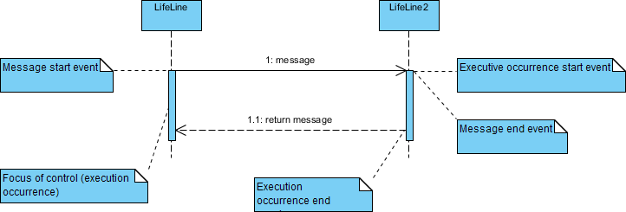

Sequence Fragments
  - Sequence fragments make it easier to create and maintain accurate sequence diagrams
  - A sequence fragment is represented as a box, called a combined fragment, which encloses a portion of the interactions within a sequence diagram
  - The fragment operator (in the top left cornet) indicates the type of fragment
  - Fragment types: ref, assert, loop, break, alt, opt, neg

Operator Fragment Type
alt Alternative multiple fragments: only the one whose condition is true will execute.
opt Optional: the fragment executes only if the supplied condition is true. Equivalent to an alt only with one trace.
par Parallel: each fragment is run in parallel.
loop Loop: the fragment may execute multiple times, and the guard indicates the basis of iteration.
region Critical region: the fragment can have only one thread executing it at once.
neg Negative: the fragment shows an invalid interaction.
ref Reference: refers to an interaction defined on another diagram. The frame is drawn to cover the lifelines involved in the interaction. You can define parameters and a return value.
sd Sequence diagram: used to surround an entire sequence diagram.

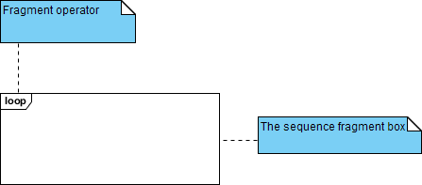



Collaboration Diagram (Communication diagram)

Collaboration diagrams (known as Communication Diagram) are used to show how objects interact to perform the behavior of a particular use case, or a part of a use case. Along with sequence diagrams, collaboration are used by designers to define and clarify the roles of the objects that perform a particular flow of events of a use case. They are the primary source of information used to determining class responsibilities and interfaces.

      - A Collaboration is a collection of named objects and actors with links connecting them. They collaborate in performing some task.
      - A Collaboration defines a set of participants and relationships that are meaningful for a given set of purposes
      - A Collaboration between objects working together provides emergent desirable functionalities in Object-Oriented systems
      - Each object (responsibility) partially supports emergent functionalities
      - Objects are able to produce (usable) high-level functionalities by working together
      - Objects collaborate by communicating (passing messages) with one another in order to work together
Notations of Collaboration Diagram

Objects
An object is represented by an object symbol showing the name of the object and its class underlined, separated by a colon:
Object_name : class_name
You can use objects in collaboration diagrams in the following ways:
- Each object in the collaboration is named and has its class specified
- Not all classes need to appear
- There may be more than one object of a class
- An object’s class can be unspecified. Normally you create a collaboration diagram with objects first and specify their classes later.
- The objects can be unnamed, but you should name them if you want to discriminate different objects of the same class.

Actors
Normally an actor instance occurs in the collaboration diagram, as the invoker of the interaction. If you have several actor instances in the same diagram, try keeping them in the periphery of the diagram.
- Each Actor is named and has a role
- One actor will be the initiator of the use case

Links
Links connect objects and actors and are instances of associations and each link corresponds to an association in the class diagram
Links are defined as follows:
- A link is a relationship among objects across which messages can be sent. In collaboration diagrams, a link is shown as a solid line between two objects.
- An object interacts with, or navigates to, other objects through its links to these objects.


- A link can be an instance of an association, or it can be anonymous, meaning that its association is unspecified.
- Message flows are attached to links, see Messages.

Messages
A message is a communication between objects that conveys information with the expectation that activity will ensue. In collaboration diagrams, a message is shown as a labeled arrow placed near a link.
- The message is directed from sender to receiver
- The receiver must understand the message
- The association must be navigable in that direction

Steps for Creating Collaboration Diagrams

- Identify behavior whose realization and implementation is specified
- Identify the structural elements (class roles, objects, subsystems) necessary to carry out the functionality of the collaboration
  - Decide on the context of interaction: system, subsystem, use case and operation
- Model structural relationships between those elements to produce a diagram showing the
context of the interaction
- Consider the alternative scenarios that may be required
  - Draw instance level collaboration diagrams, if required.
  - Optionally draw a specification level collaboration diagram to summarize the alternative scenarios in the instance level sequence diagrams



State–Chart Diagrams

Purpose of State-Chart diagram:

State-chart diagram describes the flow of control from one state to another state. States are defined as a condition in which an object exists and it changes when some event is triggered. The most important purpose of State-chart diagram is to model lifetime of an object from creation to termination.

Notations of State-Chart diagram:

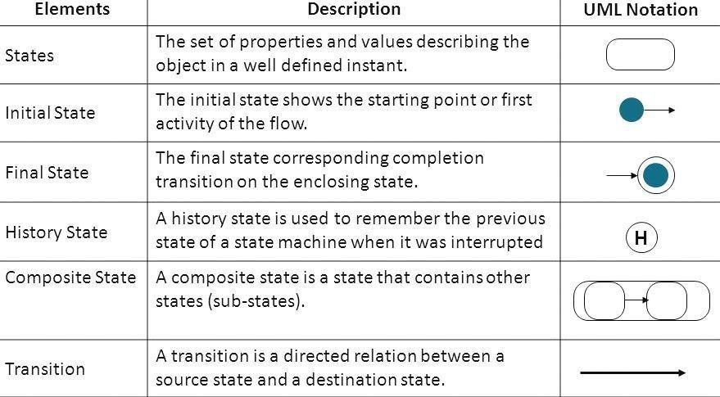



Activity Diagram

Purpose of Activity Diagram:
An activity diagram shows business and software processes as a progression of actions. These actions can be carried out by people, software components or computers. Activity diagrams are used to describe business processes and use cases as well as to document the implementation of system processes.

Notations of Activity Diagram:

Notation Description | Visual Representation
Initial State or Start Point  - A small filled circle followed by an arrow represents the initial action state or the start point for any activity diagram. | 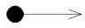
Activity or Action State  - Anactionstaterepresentsthenon- interruptibleactionofobjects.Youcandrawanactionstateu singarectanglewith rounded corners. | 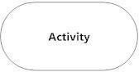
Action Flow
- It Action flows, also called edges and paths, illustrate the transitions from one action state to another. They are usually drawn with an arrowed line.
Object Flow  - Object flow refers to the creation and modification of objects by activities. An object flow arrow from anactiontoanobjectmeansthattheactioncreatesorinfluenc estheobject. | 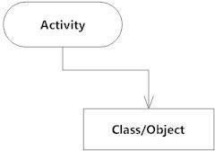
Decisions and Branching  - A diamond represents a decision with alternate paths. When an activity requires a decision prior to moving on to the next activity, add a diamond between the two activities. | 



Synchronization  - A join node joins multiple concurrent flows back into a single outgoing flow.  - A fork and join mode used together are often referred to as synchronization. | 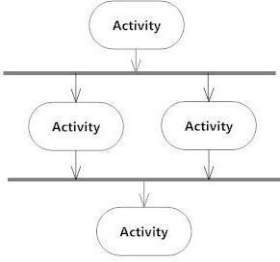
Time Event  - This refers to an event that stops the flow for a time; an hour glass depicts it. | 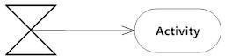
Merge Event  - A merge event brings together multiple flows that are not concurrent. | 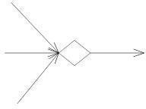
Sent and Received Signals  9 They appear in pairs of sent and received signals, because the state can't change until a response is received. | 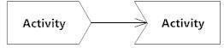
Interrupting Edge  - They An event, such as a cancellation, that interrupts the flow denoted with a lightning bolt. | 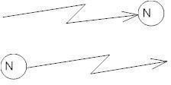



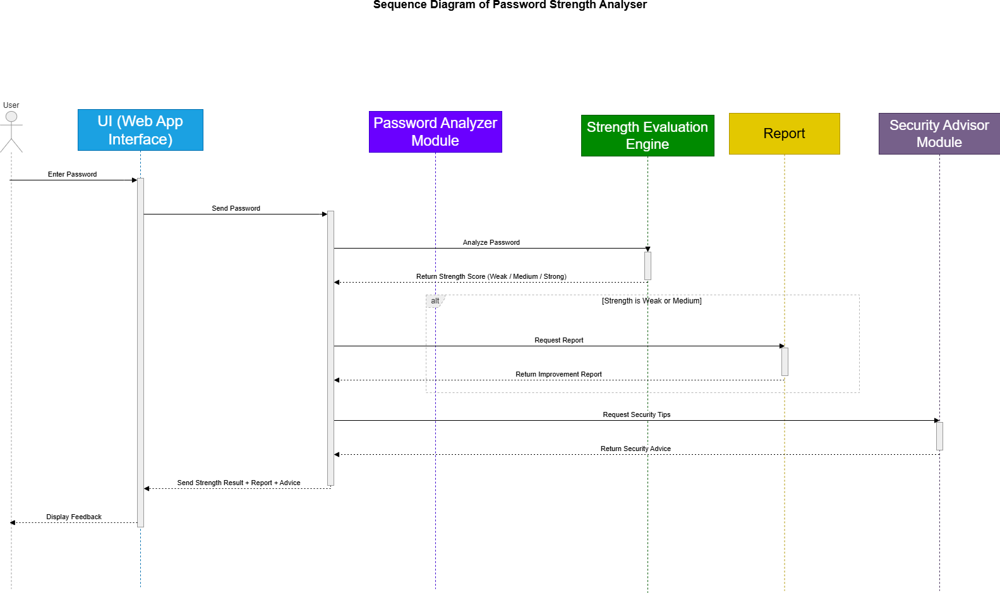
Fig 1 Sequence Diagram of Password Strength Analyzer
Fig 2 Collaboration Diagram for Password Strength Analyzer


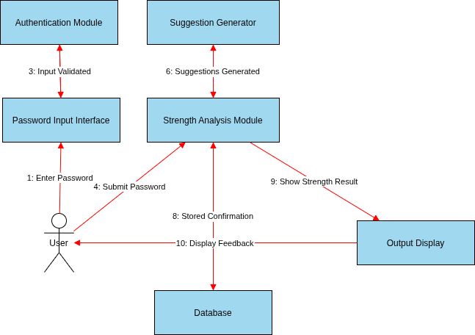

Fig 3 State Chart Diagram for Password Strength Analyzer


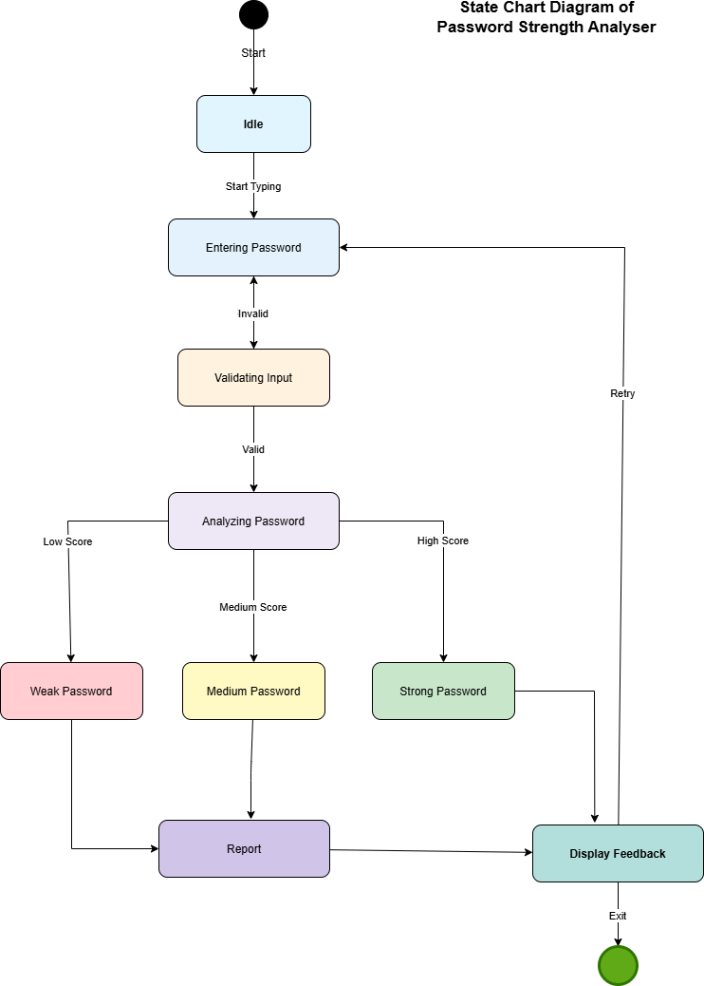


Fig 4 Activity Diagram Password Strength Analyzer
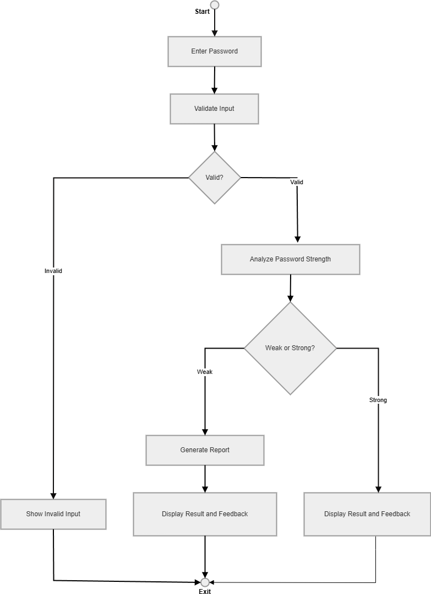


Practical 10
(Development and Management of Software using Reverse Engineering)

Step 1: Existing Solution and URL

Software: Tally ERP (Accounting Software) URL: https://tallysolutions.com

Step 2: Existing Features with Details
- Accounting management (ledger, balance sheet, profit/loss)
- GST billing and tax calculation
- Inventory management
- Multi-user access (limited in local network)
- Report generation (financial reports, sales reports)
- Data stored locally on system/server

Step 3: Technology Used for Existing Solution
- Desktop-based application
- Uses Tally Definition Language (TDL)
- Local database storage
- Client-server architecture (basic level)
- Windows-based environment

Step 4: Reasons to Perform Reverse Engineering
- Understand how data flow and accounting logic works
- Identify limitations in remote access and collaboration
- Improve scalability for modern cloud usage
- Enhance user experience and accessibility
- Build a more flexible and modern system

Step 5: Drawbacks of Existing Solution
- Not fully cloud-based
- Limited remote access (needs setup like VPN/RDP)
- UI is outdated and not beginner-friendly
- Difficult integration with modern apps
- Backup and data sync is manual
- Not optimized for mobile devices



Step 6: Features to be Added / Updated / Replaced / Removed

Added
- Cloud-based access (use from anywhere)
- Mobile app support
- Real-time collaboration (multiple users simultaneously)
Updated
- Modern UI/UX design
- Automated backup and sync
- Faster report generation
Replaced
- Local storage → Cloud database
- Manual sharing → Live shared workspace
Removed
- Dependency on local machine
- Complex manual configurations

Step 7: Technologies to be Used
- Frontend: React / Android (Kotlin)
- Backend: Node.js / Python
- Database: PostgreSQL / Firebase
- Cloud: AWS / Azure
- API integration for GST and financial data
- Secure authentication (JWT / Oauth)

Step 8: Advantages of Updated Solution
- Access from anywhere without setup
- Better collaboration for teams
- Automatic data backup
- Scalable for businesses
- Easy integration with other software
- Beginner-friendly interface

Step 9: Blueprint of Updated Solution (Wireframe)
- Main Screens:
- Login Page
- Dashboard (summary of business)
- Accounts Page (ledger, entries)
- Inventory Page
- Reports Page
- Settings



- Flow:
Login → Dashboard → Select Module → Perform Action → Save → Auto Sync

Step 10: Comparison

Feature | Existing (Tally) | Updated Solution
Access | Local / LAN | Cloud-based
UI | Old | Modern
Collaboration | Limited | Real-time
Backup | Manual | Automatic
Device Support | PC only | PC + Mobile
Integration | Limited | API-based



Practical 11
(Development and management of software using Forward Engineering)

Step 1: Existing Solution and URL

Software: Vyapar App (Business Accounting & Billing)
URL: https://vyaparapp.in

Step 2: Existing Features with Details
- Billing and invoicing (GST supported)
- Expense tracking
- Inventory management
- Basic financial reports
- Works on mobile and desktop
- Offline functionality available

Step 3: Technology Used for Existing Solution
- Android (Java/Kotlin)
- Desktop app (Windows-based)
- Local database (SQLite)
- Limited cloud backup
- Basic API integrations

Step 4: Drawbacks of Existing Solution
- Cloud features are not strong
- Data sync issues between devices
- UI is simple but not scalable for large businesses
- Limited third-party integrations


- No strong multi-user role management

Step 5: How to Execute Forward Engineering (Methodology, Approach, Life Cycle) Methodology:
- Agile Development (incremental improvements)

Approach:

- Requirement Analysis (understand business needs)

- System Design (architecture planning)

- Development (modular coding)

- Testing (unit + integration testing)

- Deployment (cloud + app release)

- Maintenance (updates and bug fixes)

Life Cycle:

Requirement → Design → Development → Testing → Deployment → Maintenance

Step 6: Features to be Added
  - Real-time multi-user collaboration
  - Cloud workspace for businesses
  - Role-based access (admin, staff, accountant)
  - Live dashboard with analytics
  - API integrations (payment gateways, banking)
  - Auto GST filing assistance
  - Cross-device seamless sync



Step 7: Technologies to be Used
  - Frontend: React (Web), Android (Kotlin)
  - Backend: Node.js / Django
  - Database: PostgreSQL / MongoDB
  - Cloud: AWS / Google Cloud
  - Real-time: WebSockets / Firebase
  - Security: JWT Authentication

Step 8: Advantages of Updated Solution
  - Fully cloud-enabled system
  - Better team collaboration
  - Scalable for small to large businesses
  - Faster and real-time data updates
  - Secure and reliable
  - Works on multiple devices smoothly

Step 9: Blueprint of New Solution (Wireframe) Main Structure:
  - Login / Signup
  - Dashboard (business overview)
  - Sales / Billing Section
  - Inventory Section
  - Reports & Analytics
  - User Management
  - Settings



Layout Idea:
  - Left sidebar (navigation)
  - Top bar (search + profile)
  - Main content area (dynamic data)

Flow:
Login → Dashboard → Select Feature → Perform Action → Auto Save → Sync

Step 10: Comparison

Feature | Existing (Vyapar) | New Solution
Collaboration | Limited | Real-time
Cloud | Partial | Fully cloud-based
Sync | Manual/Delayed | Instant
Roles | Basic | Advanced role system
Integration | Limited | API-based
Scalability | Small business | Small → Large business



Practical 12

(Development and Management of Software using Re-Engineering) Step 1: Existing Solution and URL
Software: Notepad (Windows)
URL: https://apps.microsoft.com/store/detail/windows-notepad

Step 2: Existing Features with Details
  - Simple text editing
  - Create, edit, and save .txt files
  - Basic find and replace
  - Lightweight and fast
  - No formatting (plain text only)

Step 3: Technology Used for Existing Solution
  - Desktop application (Windows)
  - Built using C/C++
  - Local file system storage
  - No database or cloud support

Step 4: Reasons to Perform Re-Engineering
  - Improve functionality while keeping it lightweight
  - Add modern features without making it complex
  - Enhance usability for developers and students
  - Support multi-device usage
  - Improve productivity



Step 5: Drawbacks of Existing Solution
  - No syntax highlighting
  - No auto-save
  - No cloud sync
  - No multi-tab support (older versions)
  - No collaboration features
  - Very limited functionality

Step 6: Things Considered from Existing Solutions
  - Fast performance
  - Simple UI
  - Low system usage
  - Easy to use
(These should be preserved)

Step 7: Features to be Added / Updated / Replaced / Removed Added
  - Multi-tab editing
  - Auto-save feature
  - Basic syntax highlighting (for code)
  - Cloud sync (optional)

Updated
  - UI (clean but modern)


  - File handling (recent files, quick access)

Replaced
  - Single file editing → Multi-document interface

Removed
  - Nothing major (keep it simple)

Step 8: Technologies to be Used
  - Frontend: Electron / .NET (for desktop app)
  - Backend (optional): Node.js (for sync)
  - Storage: Local + Cloud (Firebase)
  - Programming: JavaScript / C#

Step 9: Advantages of Updated Solution
  - Still lightweight but more powerful
  - Useful for developers and normal users
  - Better productivity with tabs and auto-save
  - Optional cloud access
  - Modern yet simple interface

Step 10: Blueprint of Updated Solution (Wireframe) Main Layout:
  - Top bar (File, Edit, View)
  - Tab section (multiple files open)
  - Text editor area
  - Status bar (line, column info)

Flow:
Open App → Create/Open File → Edit → Auto Save → Sync (optional)



Step 11: Comparison

Feature | Existing (Notepad) | Re-Engineered Solution
Tabs | Limited | Multi-tab
Auto-save | No | Yes
Syntax Highlight | No | Basic
Cloud Sync | No | Optional
UI | Very basic | Modern simple
Use Case | Basic text | Text + light coding

